The public is requested to fill out a "Speaker Card" to address the Board on any item of the agenda prior to the Board taking action on an item. Comments from the public on Agenda items will be heard only when the respective item is being considered. Comments from the public on other matters not appearing on the Agenda that is within the Board's subject matter jurisdiction will be heard during the Public Comment period. Public comment is limited to 2 minutes per speaker, unless waived by the presiding officer of the Board. The chair reserves the right to change the amount of time given to speakers depending on circumstances. As a covered entity under Title II of the Americans with Disabilities Act, the City of Los Angeles does not discriminate on the basis of disability and upon request, will provide reasonable accommodation to ensure equal access to its programs, services, and activities. Sign language interpreters, assistive listening devices, or other auxiliary aids and/or services may be provided upon request. Reports and other committee reference materials may be seen on our website under each committee's meeting agenda. Agendas are posted publicly in the window of the Sherman Oaks Branch Library 14245 Moorpark Street, Sherman Oaks 91423. Printed copies of board and committee agendas can be obtained by sending a written public records request after the document has been published to PO Box 5721, Sherman Oaks 91413. A check for $1 plus 10 cents per page plus 49 cents postage made out to the City of Los Angeles must be included with the request. If additional payment is required, you will be notified. For information on the s process for board action reconsideration, stakeholder grievance policy, or any other procedural matters related to this Council, please consult the Sherman Oaks Neighborhood Council Bylaws. The Bylaws are available at our Board meetings and our website www.shermanoaksnc.org
.
AGENDA
 | CITY OF LOS ANGELES
Committee Members:  Debbie Kozin Chair  Lee Rubenstein  Donna Horn  Jill Croce  Leigh O’ Bryne | CALIFORNIA | SHERMAN OAKS  NEIGHBORHOOD COUNCIL  P O Box 5721  Sherman Oaks, CA 91413  (818) 503-2399  www.shermanoaksnc.org

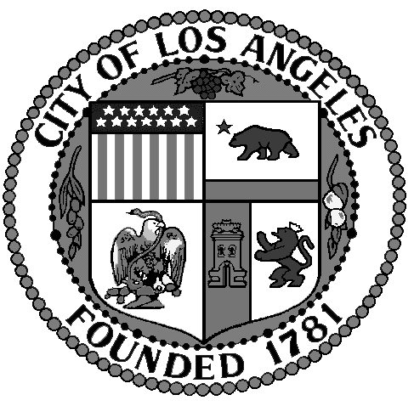

Sherman Oaks Neighborhood Council
Animal Welfare Committee Meeting Agenda
Wednesday August 3rd 2016 6:30
Marie Callendar
14743 Ventura Blvd.
Sherman Oaks, CA 91403

- Call to Order by Debbie Kozin, Chair
- Roll Call
- Review and approval of minutes
- Introduction of elected officials and staff
- Questions and answers.
- Public forum: comments by the public on non-agenda items within the Committee’s jurisdiction
- Chair’s Report

7) Returning Business. Discussion and possible motion to vote
a) Execution of training classes at LARPBO
b) Survey for people taking training classes at LARPBO
c) Therapy Dogs for East Valley Adult Center
on funds for beds at East Valley

ii) Public comment and discussion
8) Committee Business
9).Announcements from the Committee on subject matters within SONC’s jurisdiction
10) Adjourn

