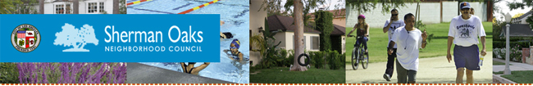
Sherman Oaks Neighborhood Council SONC
SONC Meeting
Monday, April 13, 2015
6:30 p.m. Reception and Candidates' Forum
Sherman Oaks Elementary School Auditorium
14780 Dickens Street
(one block south of Ventura, just east of Kester)
Refreshments
Candidates' Forum
for
School Board and Council District 4
* Moderator will be Dan Schnur, Director of the Jesse M. Unruh Institute of Politics at USC
* Top TWO Candidates for LAUSD Board of Education
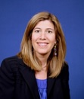  Tamar Galatzan |  | 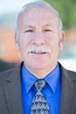  Scott Schmerelson
*Candidate Forum with the top TWO candidates in the runoff election May 19 for LAUSD Board of Education, District 3.
Tamar Galatzan, incumbent School Board member will face Scott Schmerelson, Administrator and former teacher.
**********************************************
* The Top TWO candidates for CD4
Carolyn Ramsay and David Ryu will face each other in the May 19 runoff to represent Sherman Oaks on the City Council
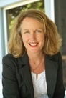  Carolyn Ramsay |  | 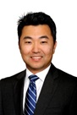  David-Ryu

**********************************************
The March 3 primary election narrowed the field of 14 candidates down to the Top TWO who will face each other in the May 19 runoff election to fill the vacancy for the seat representing CD4 on the LA City Council.
Carolyn Ramsay and David Ryu received the most votes seeking to replace termed- out Councilmember Tom LaBonge. Ramsay had been LaBonge's Chief of Staff and garnered 15.25% of the vote. Ryu, is an executive with an LA non-profit hospital and Community Health Center and received 14.9% of the vote.
You don't want to miss this informative and exciting meeting!

