Committee Members  Howard Katchen, Chair  Linda Brooks  David Bustan  Carolyn Casavan  Daniel Crisci  Richard Marciniak  Lisa Petrus  Matt Plotkin | CALIFORNIA | SHERMAN OAKS  NEIGHBORHOOD COUNCIL  P O Box 5721  Sherman Oaks, CA 91413  (818) 503-2399  www.shermanoaksnc.org  OR CONTACT  Department of Neighborhood Empowerment  200 North Spring Street, 20th Floor  Los Angeles, CA. 90012  (213) 978-1551 phone  (213) 978-1751 fax  or call 311 for information

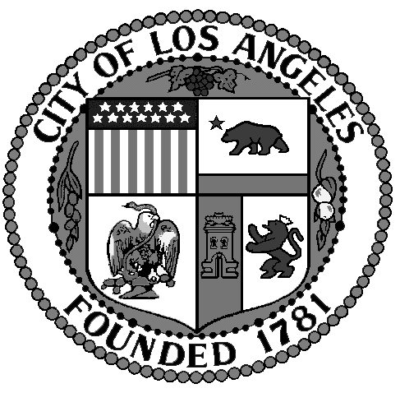
Sherman Oaks Neighborhood
Council

FINANCE COMMITTEE

Thursday, September 18, 2014
at 5:30 p.m.

Westfield Fashion Square

Food Court – 2nd Floor
14006 Riverside Drive
Sherman Oaks, CA. 91423

AGENDA

- Call to Order by Howard Katchen, Treasurer and Finance Committee Chair
- Review and approve meeting minutes of July 31, 2014
- Review, discuss and approve current Sherman Oaks Neighborhood Council financial report and current financial status
- Presentation, discussion and possible action: funds request from SONC Green & Beatification Committee for $200.00 to purchase plants for Ernie’s Way
- Presentation, discussion and possible action: Reallocate $2,500.00 from Outreach events budget line item to Neighborhood Purposes Grant
- Non agenda items, other business
- Adjournment

