Committee Members  Howard Katchen, Chair  Daniel Crisci  Linda Brooks  David Bustan  Carolyn Casavan  Richard Marciniak  Matt Plotkin | CALIFORNIA | SHERMAN OAKS  NEIGHBORHOOD COUNCIL  P O Box 5721  Sherman Oaks, CA 91413  (818) 503-2399  www.shermanoaksnc.org  OR CONTACT  Department of Neighborhood Empowerment  200 North Spring Street, 20th Floor  Los Angeles, CA. 90012  (213) 978-1551 phone  (213) 978-1751 fax  or call 311 for information

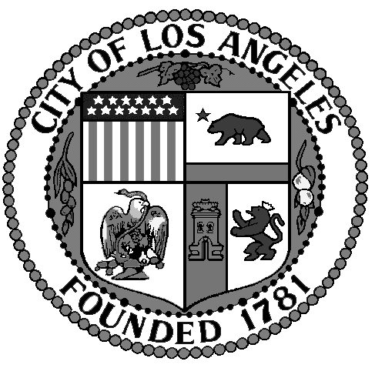
Sherman Oaks Neighborhood
Council

FINANCE COMMITTEE

Thursday, May 29, 2014
at 5:30 p.m.

Westfield Fashion Square

Food Court – 2nd Floor
14006 Riverside Drive
Sherman Oaks, CA. 91423

AGENDA

- Call to Order by Howard Katchen, Treasurer and Finance Committee Chair
- Review and approve Special Meeting Minutes of April 3, 2014
- Review, discuss and approve current Sherman Oaks Neighborhood Council financial report and current financial status
- Review, discuss and approve budget for fiscal year 2014 – 2015
- Present and discuss draft guidelines for funds requests
- NC Budget Advocates Update
- Non agenda items, other business
- Adjournment

