Sherman Oaks Neighborhood Council

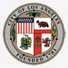

MINUTES OF FINANCE COMMITTEE MEETING
Thursday, May 1, 2014
Location: Food Court in Fashion Square Mall in Sherman Oaks, CA

There was not a quorum and therefore no meeting.

Respectfully submitted,
Linda Brooks

