Committee Members  Howard Katchen, Chair  Linda Brooks  Richard Marciniak  Matt Plotkin  Ron Ziff | CALIFORNIA | SHERMAN OAKS  NEIGHBORHOOD COUNCIL  P O Box 5721  Sherman Oaks, CA 91413  (818) 503-2399  www.shermanoaksnc.org  OR CONTACT  Department of Neighborhood Empowerment  200 North Spring Street, 20th Floor  Los Angeles, CA. 90012  (213) 978-1551 phone  (213) 978-1751 fax  or call 311 for information

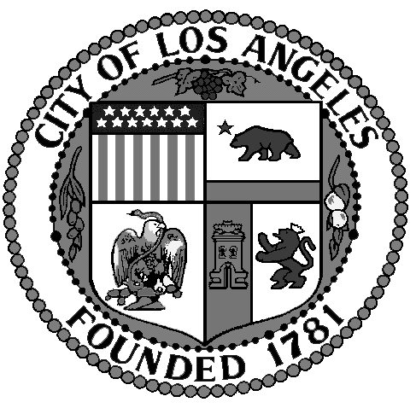
Sherman Oaks Neighborhood
Council

FINANCE COMMITTEE

Thursday, January 30, 2014
At 6:00 p.m.

Westfield Fashion Square

Food Court – 2nd Floor
14006 Riverside Drive
Sherman Oaks, CA. 91423

AGENDA

- Call to Order by Howard Katchen, Treasurer and Finance Committee Chair
- Review and approve Meeting Minutes of November 21, 2013
- Review, discuss and approve current Sherman Oaks Neighborhood Council financial report and current financial status
- Rick Rabins, $6,000.00 funding request for Village Gardeners' mixed-media mural project
- Carolyn Casavan, Chair Beautification Committee, request for SONC Election funds
- Update Neighborhood Councils checking account
- Non agenda items, other business
- Adjournment

