Committee Members  Howard Katchen, Chair  Linda Brooks  Richard Marciniak  Matt Plotkin  Ron Ziff | CALIFORNIA | SHERMAN OAKS  NEIGHBORHOOD COUNCIL  P O Box 5721  Sherman Oaks, CA 91413  (818) 503-2399  www.shermanoaksnc.org  OR CONTACT  Department of Neighborhood Empowerment  200 North Spring Street, 20th Floor  Los Angeles, CA. 90012  (213) 978-1551 phone  (213) 978-1751 fax  or call 311 for information

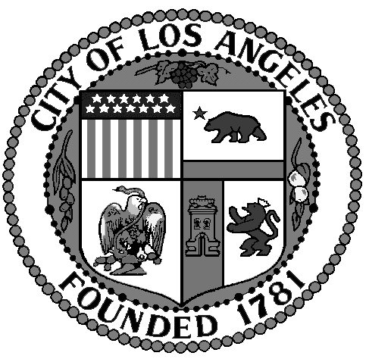
Sherman Oaks Neighborhood
Council
FINANCE COMMITTEE
Thursday, September 26, 2013
At 6:00 p.m.

Westfield Fashion Square

Food Court – 2nd Floor
14006 Riverside Drive
Sherman Oaks, CA. 91423

AGENDA

- Call to Order by Howard Katchen, Treasurer and Finance Committee Chair
- Review and approve Meeting Minutes of August 29, 2013
- Review, discuss and approve Sherman Oaks Neighborhood Council financial report and current financial status
- Rick Rabins, Village Gardners Mural Project, funds request $6,000.00
- Conor Lynch Foundation funds request for Porto-potties at Run/Walk in Honor of Conor on October 27, 2013
- Allocate up to $200.00 to purchase a Tablet or similar device with internet, WI-FI capability for use during the Sherman Oaks Street Fair to add stakeholders contact information directly to SONC’s website database
- Update Neighborhood Councils checking account
- Non agenda items, other business
- Adjournment

