Committee Members  Howard Katchen, Chair  Linda Brooks  Richard Marciniak  Matt Plotkin  Ron Ziff | CALIFORNIA | SHERMAN OAKS  NEIGHBORHOOD COUNCIL  P O Box 5721  Sherman Oaks, CA 91413  (818) 503-2399  www.shermanoaksnc.org  OR CONTACT  Department of Neighborhood Empowerment  334-B E. Second Street  Los Angeles, Ca 90012  (213) 847-7164 phone  (213) 485-4608 fax  or call 311 for information

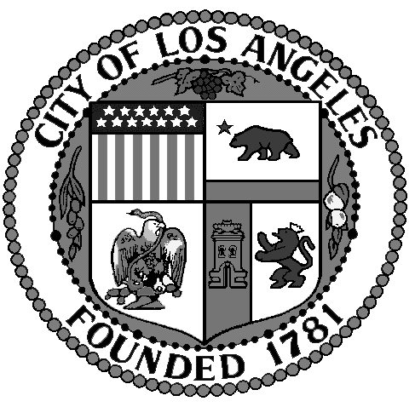
Sherman Oaks Neighborhood
Council
FINANCE COMMITTEE
Thursday, May 30, 2013
At 5:30 p.m.
Sherman Oaks Fashion Square – Food Court

REVISED AGENDA

- Call to Order by Howard Katchen, Treasurer and Finance Committee Chair
- Review and approve Meeting Minutes of April 25, 2012
- Review, discuss and approve Sherman Oaks Neighborhood Council current Financial status
- Action item: $2,500.00 Law Enforcement Torch Run
- New fiscal year Budget Package status
- Review and approve proposed Budget for new fiscal year 2013 – 2014
- Non agenda items, other business: SONC banners to hang in Sherman Oaks
- Adjournment

