The public is requested to fill out a "Speaker Card" to address the Board on any item of the Agenda prior to the Board taking action on an item. Comments from the public on Agenda items will be heard only when the respective item is being considered. Comments from the public on other matters not appearing on the Agenda that is within the Board's subject matter jurisdiction will be heard during the Public Comment period. Public comment is limited to 2 minutes per speaker, unless waived by the presiding officer of the Board. The chair reserves the right to change the amount of time given to speakers depending on circumstances. As a covered entity under Title II of the Americans with Disabilities Act, the City of Los Angeles does not discriminate on the basis of disability and upon request, will provide reasonable accommodation to ensure equal access to its programs, services, and activities. Sign language interpreters, assistive listening devices, or other auxiliary aids and/or services may be provided upon request. Reports and other committee reference materials may be seen on our website under each committee's meeting agenda. Agendas are posted publicly in the window of the Sherman Oaks Branch Library 14245 Moorpark Street, Sherman Oaks 91423. Printed copies of board and committee agendas can be obtained by sending a written public records request after the document has been published to PO Box 5721, Sherman Oaks 91413. A check for $1 plus 10 cents per page plus 49 cents postage made out to the City of Los Angeles must be included with the request. If additional payment is required, you will be notified.
.
AGENDA
 | CITY OF LOS ANGELES
Committee Members:  Debbie Kozin – Chair  Donna Horn  Sherry Brewer, Alternate | CALIFORNIA | SHERMAN OAKS  NEIGHBORHOOD COUNCIL  P O Box 5721  Sherman Oaks, CA 91413  (818) 503-2399  www.shermanoaksnc.org

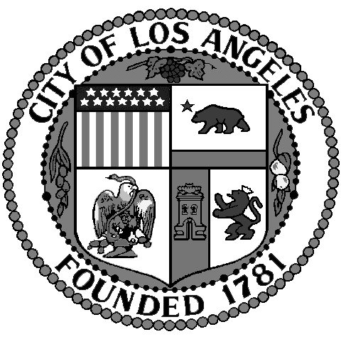

Sherman Oaks Neighborhood Council
Animal Welfare Committee Agenda
Tuesday, November 17, 2015 6:30 PM
New York Bagel Cafe
14423 Ventura Blvd.
Sherman Oaks, CA

- Call to Order by Debbie Kozin, Chair.
- Roll Call.
- Review and approval of Minutes.
- Introduction of elected officials and staff.
- Public comment on non- agenda items.
6. Announcements:
A. Cutting Ribbon Ceremony David Ryu at East Valley Animal Shelter 14409 Vanowen Street, Van Nuys, CA 91405 November 19, 2015; 10AM.
B) Towels and Blankets for East Valley Shelter to be delivered on November 19, 2015. Please bring any extra blankets and towels to the meeting.

7. Committee discussion and possible motion and vote:
A. Sherman Oaks Neighborhood Councils possible support of letter sent by Tarzana Animal Welfare Committee to Councilmen Koretz and Blumenfield. Jeff Mausner to speak regarding said letter and other efforts and activities of the Tarzana Animal Welfare Committee.

B. Discussion of appointing a Committee Member to pursue outreach and encourage Neighborhood Councils to form Animal Welfare Committees

8. New Business. Discussion and possible motion to vote:

A. Write and distribute newsletter of low cost no charge animal services available to the community.

B. Possible Fundraising and Adoption Events at local car dealerships

9. New Business-Committee members and members of the public may bring up new business that they would like the committee to consider.

10. Adjourn.

