MINUTES
 | CITY OF LOS ANGELES
Committee Members:  Debbie Kozin – Chair  Donna Horn  Anne Friel  Lee Rubenstein  Leigh O’Bryan  Jill Croce  JD Disalvatore  Sherry Brewer, Alternate | CALIFORNIA | SHERMAN OAKS  NEIGHBORHOOD COUNCIL  P O Box 5721  Sherman Oaks, CA 91413  (818) 503-2399  www.shermanoaksnc.org

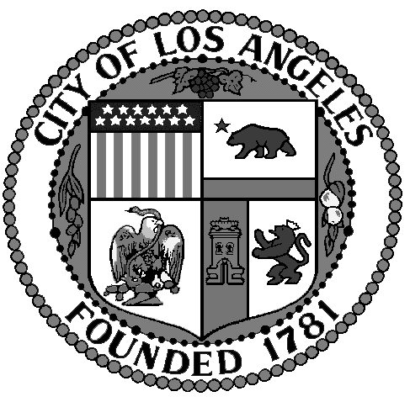

Sherman Oaks Neighborhood Council
Animal Welfare Committee Minutes
Wednesday, May 11 at 6:30 p.m.
Sherman Oaks Library, 14245 Moorpark Street
Sherman Oaks, CA

1. Meeting was called to order by Debbie Kozin at 6:30 pm. There were 8 attendees in total including Committee Members, shelter volunteers and public.

2. Roll Call.

3. Approved Minutes from last meeting.

4. Announcements:

Community Wide Pet Fair (further discussion):
Confirmed, voted and passed: Date of Saturday November 5, 2016 for the Pet Fair to be held at the Sherman Oaks/East Valley Senior Center, 5056 Van Nuys Blvd., Sherman Oaks, CA 91423.

Discussed the possibility of the Chamber of Commerce to become involved with the fair. Flyers to contain requests for donated cans/bags of dog food and drop off containers will be set up at the fair. Contact large donators: Rachel Ray, Ellen DeGeneres, et al.

Discussed the next steps necessary for the fair and will have this information by our next meeting:

a) Need to obtain requirements and regulations (insurance, etc.)
b) Need to obtain a budget.
c) Need to visit the Senior Center re: tables, chairs, parking, etc.

5. Briefly discussed donation of food and supplies for dogs to food banks – (M.E.N.D and others) [put on hold for a month, focus on the fair].

6. Discussed training classes by LABPO of (large) adopted and fostered dogs from East Valley Shelter and how to obtain financial backing.

Continue to post on the Nextdoor/Library Square website for donating blankets and requested items for the East Valley Animal Shelter. Donations can be dropped off directly to the Shelter or at the District Offices at the following locations: Sherman Oaks: 13907 Ventura Blvd., Suite 104 (Tuesday thru Friday) or Toluca Lake, 10116 Riverside Drive, Ste 200 (on Thursday and Friday).

The Friends of the East Valley Shelter have created a wish list on Amazon.
Link: http://www.amazon.com/registry

7. Topics Further Briefly Discussed:

A. Donations of pet food, leashes, collars to local food banks.
B. Gathering list of low cost Vets and food banks.

Adjourned 8:00 PM.

